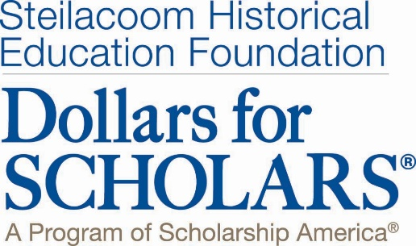

Scholarships Available, 2017

All scholarships will be awarded based on your online profile, completed at http://shef.dollarsforscholars.org

All scholarships will be awarded based on

Steilacoom Historical Education Foundation (SHEF) Scholarships –Several of various amounts, minimum is $750.00

John Anderson Scholarships -- $550 each

DuPont Lions Scholarship -- $750

Steilacoom Education Association Scholarship -- $2,500

Linda and Gerry Evanson Scholarships -- $750 each

The Lucas Family Scholarships -- $750 each

Bair Family Scholarship -- $700

Dave Sellars Leadership Scholarship --$750

Jaimie Garrett Scholarship for Volunteerism - $1000

Mike & Robbie Courts Military Dependent Scholarship - $1,500

SHEF Vocational Education Scholarship - $1,000

Dr. Art Himmler Music Scholarship -- $750

Kiwanis Scholarships – 6 at $1,000 each

We Love Steilacoom Association Scholarship -- $500 each

O’Grady Family Scholarship -- $750

Allen Realtors Scholarship -- $500, renewable for 2 years

Sam Courts Scholarship -- $5000 each year for 2 years

