Creating Your Profile for SHEF Scholarships through Dollars for Scholars
1.
Go to www.shef.dollarsforscholars.org
2. Click on this tab
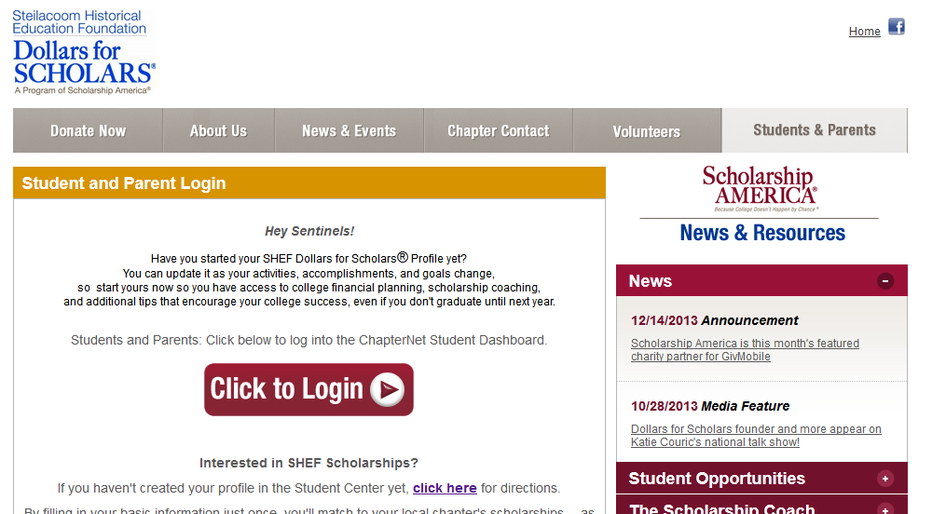
3.
5.
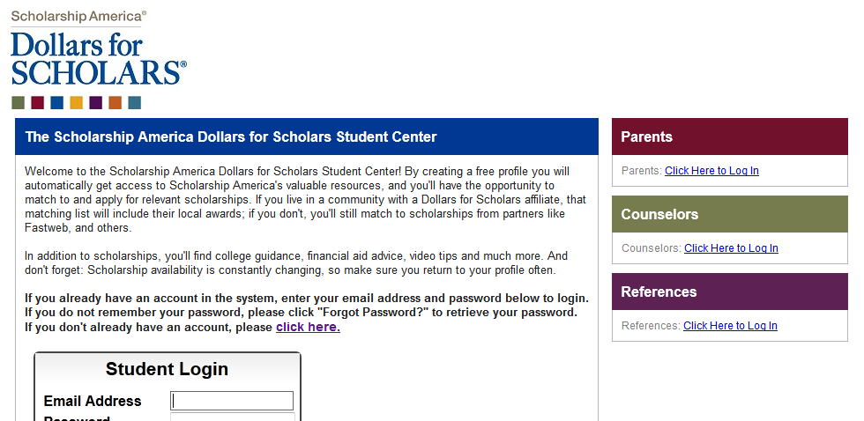
4.
After completing the first two screens, your login information will be sent to your personal email address so you can return to www.shef.dollarsforscholars.org to open your profile.
The profile has several components: Basic Information, Additional Information, Financial Information (some scholarships are based on financial need), Transcripts. You will be asked to provide email addresses for your parents, school counselor, and references if needed. They will be confidentially contacted to complete their component of your profile. Profiles can be edited as needed and circumstances change. Questions? Keep in touch: SHEFinfo@gmail.com

